Test Bank Questions (20 Questions)
IT342: Enterprise Systems
Drawn from online publisher resources

- Dunn, C.L., Cherrington, J.O., & Hollander, A. (2005). Enterprise information systems: A pattern-based approach (3rd Ed.). McGraw-Hill/Irwin. ISBN: 9780072404296
Chapter 5
- In the following flowchart segment, the most likely action to take with the customer remittance advices once they've been keyed into the system, AND the corresponding symbol to put at circle B is
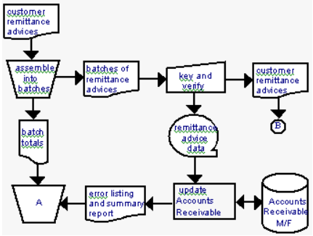
  - Discard them immediately; manual process symbol
  - Forward them to the internal audit department for review; dashed line
  - Forward them to the treasurer to compare with the monthly bank statement; dashed line
  - File them by customer number; file symbol
  - Compare them to the customer check amounts, manual process symbol
- In a system flowchart, which symbol should be used to represent a backup of the general ledger master file that can only be accessed sequentially?
  - 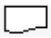
  - 
  - 
- The primary purpose of executable files is to store which of the following?
  - Business reference data
  - Transaction data
  - Word processing documents
  - Graphics documents
  - Application programs
- Which of the following can best be described as a master file?
  - A file of event data
  - An income statement
  - A trial balance
  - An accounts payable subsidiary ledger
  - A journal voucher file
- In a data flow diagram, an invoice received from a vendor is represented as a
  - Data source
  - Data sink
  - Data dictionary
  - Data flow
  - Document symbol
- All of the following are true except:
  - Flowcharts can pictorially show more than data flow diagrams because they use more different kinds of symbols.
  - Data flow diagrams do not provide any information about how data are stored, whereas flowcharts do provide such information.
  - Data flow diagrams convey the timing and sequence of events; flowcharts do not.
  - Flowcharts emphasize the flow of documents or records, whereas data flow diagrams emphasize the logical flow of data.
  - All of the above are true.
- The purpose of task level modeling in the REA ontology is
  - To design a database
  - To represent the specific workflow activities that combine to form events in a business process, and to document the flow of data through an enterprise
  - To represent the enterprise in the context of its external business partners
  - To represent the resource interconnections among the enterprise transaction cycles
  - To represent resource flows among external partners that do not directly involve the enterprise (e.g. a customer payment to a credit card company for the amount of the credit sale a store made to the customer)
- System flowcharts consist of these three simple graphical elements combined to represent various types of physical information flows and processes:
  - Charts, lines, and documents
  - Charts, symbols, and annotations
  - Symbols, lines, and documents
  - Symbols, flow lines, and areas of responsibility
  - Circles, squares, and flow lines
- Which rules should be followed to keep flowcharts uncluttered?
  - Enter narrative on charts only within symbols
  - Avoid explaining with narrative what is already adequately described by the flowchart itself
  - Place areas of responsibility with the most frequent interchange adjacent to each other to avoid long arrows
  - All of the above
  - None of the above
- Media that can be used to store data include:
  - Paper
  - Magnetic tape
  - CD-R discs
  - CD-RW discs
  - All of the above
- Which type of processing occurs during the course of a business event and provides immediate response to an information user's request
  - Online processing
  - Batch processing
  - Report-time processing
  - Real-time processing
  - Suspense processing
- Which of the following is a true statement about data flow diagram symbols?
  - Circles are used to represent data sources and sinks
  - A single straight line is used to display a store or collection of data
  - Rectangles are used to represent processes that transform data inflows into information outflows
  - Data flow lines can be straight or curved lines
  - Because approximately 25 different symbols are used in data flow diagrams, they are more difficult to prepare than are system flowcharts.

13) TF A system flowchart has the primary purpose of illustrating the logical flow of data in a system. False
14) TF The zip disk typically requires sequential storage and sequential access. False.
15) TF The key to effective information customer support is not the amount of information provided; rather it is the ability to provide accessible, useful, and timely information. True
16) TF The terms operating event and information process event are synonymous. False.
17) TF A transaction file contains batches of current source activity data. True.
18) SA Draw three of the flowcharting symbols and label them.
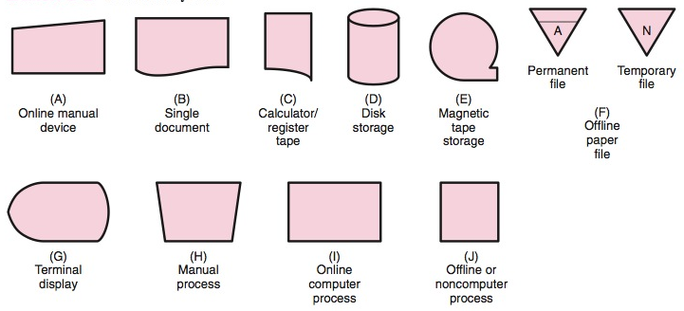

19) Define a level zero DFD.
A high-level (just under context level) representation that depicts only the very high-level processes within an information system.
20) Define an information process event.
A workflow activity that records, maintains, or reports information about one or more operating events

